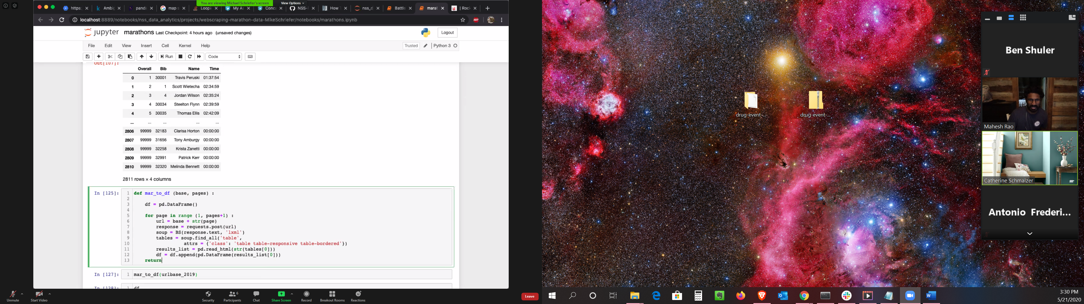

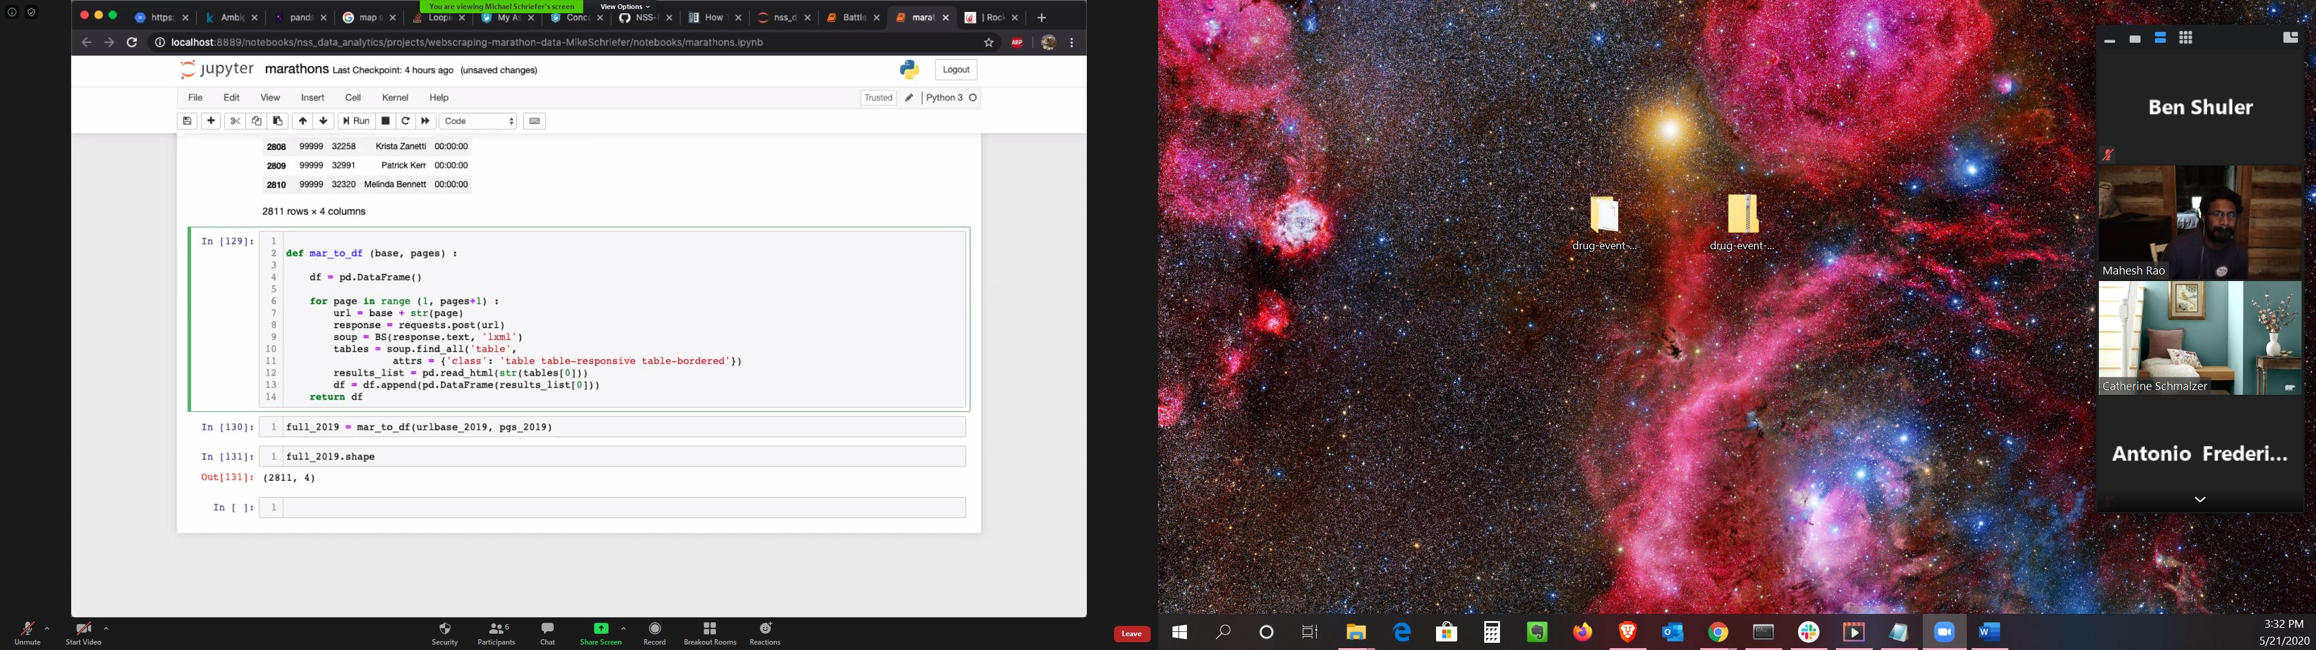

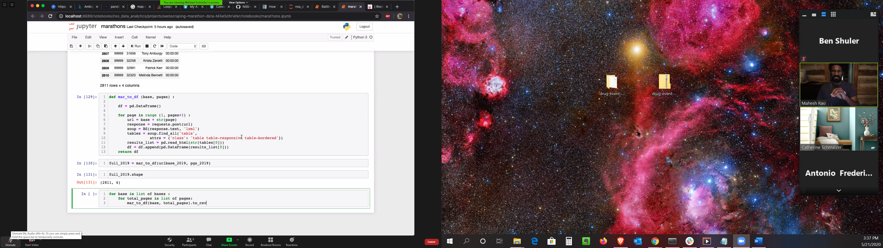

Create list of dataframe returned from function, see last cell  
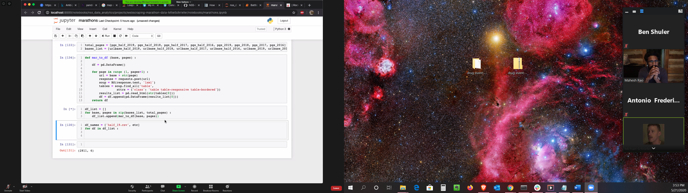Diego’s function  
